**Weather Analysis for 500 cities**

**Three observable trends based on the analysis of weather data:**

1. There is a low negative relation between the latitude and the max temperature

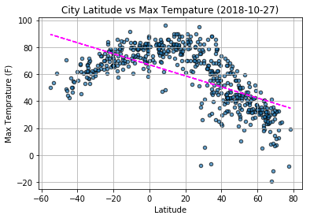

1. When visualize the relation between latitude and humidity. It’s almost no correlation

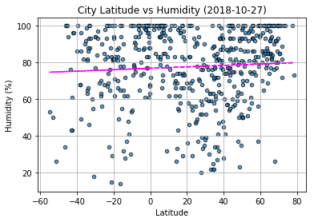

1. When visualize the relation between latitude and cloudiness. It has very slightly positive correlation

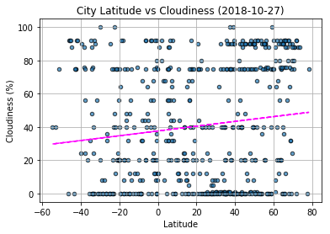

1. When visualize the relation between latitude and wind speed. It has very slightly positive correlation

